**Telecommunications Tutorial 1 – Flow Control**

1.

a) Stop-And-Wait ARQ Protocol requires sequence numbers in the frames in order to cross-check the received frame with the expected frame. If the received frame and expected frame do not match then the incorrect frame that was received is discarded. This is repeated until the expected frame is received.

b) The Bandwidth-Delay Product determines how much data can be in transit at any one time in a network. It is the product of the available bandwith and the latency (or RTT – Round Trip Time, how long an ACK takes).

Bandwidth – 2Mbit/s

Frame Size – 1000 bit

RTT – 50 ms

How much data can you send during the time it takes for 1 bit e.g an ACK to arrive at the sender?

(50 * 10-3s) * (1 * 106 ) = 50 bits

Frame of 1000 bit = 20% of Bandwidth used

2.

a) Maximum window size for a Go-Back-N ARQ and a Selective Repeat ARQ protocol that uses 7 bits to represent the sequence number in the header?

Window size = 2m -1

M = 7

Window size = 27-1 = 127

b) RTT of 100ms. Errors in the transmission are rare.

Since errors are rare there is no need for a large frame size so 2 bits would suffice. You could use a Go-Back-N ARQ. As a result you would only need a very small window size of 22 bits, thus allowing more space for data to be stored and transmitted.

c)Selective Repeat ARQ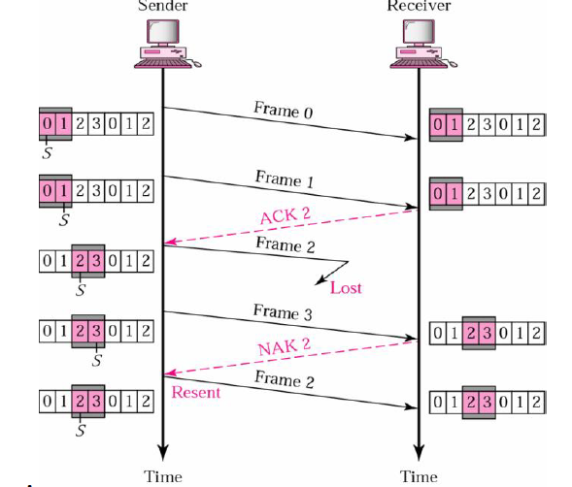

d) If the link exhibited more errors than in 2c) I would extend the frame numbers to ensure that there is a higher possibility that errors will be detected properly.

e) Go-Back-N ARQ goes back and ensures that the correct frame is received before continuing onto the next frame. However Selective Repeat ARQ continues on even when the correct ACK has not been revieved. Only when it receives an NAK will it return and re-send the frame that was lost.